**Users, groups and locacal policies exercises.**

**1.-**

We need to go to computer management and click on action->new user.

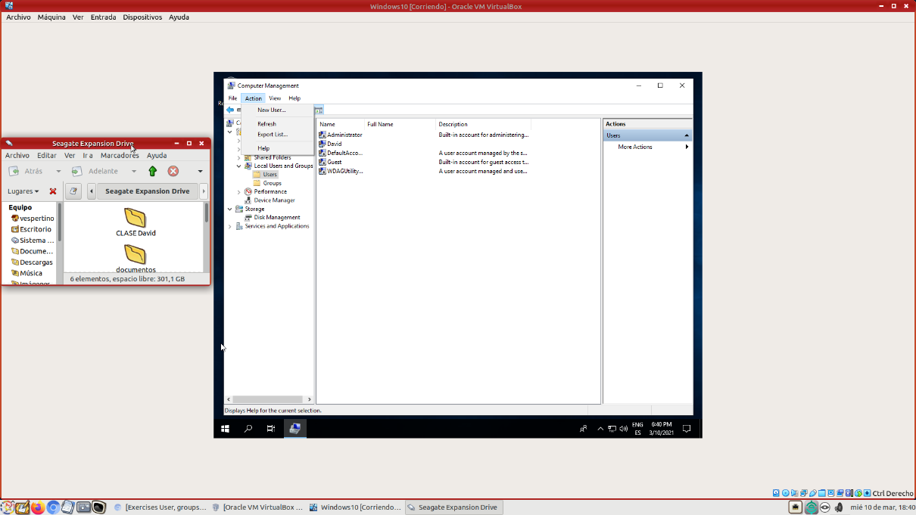

Then type all the information needed and select the “user must change passwoer at next login” checkbox.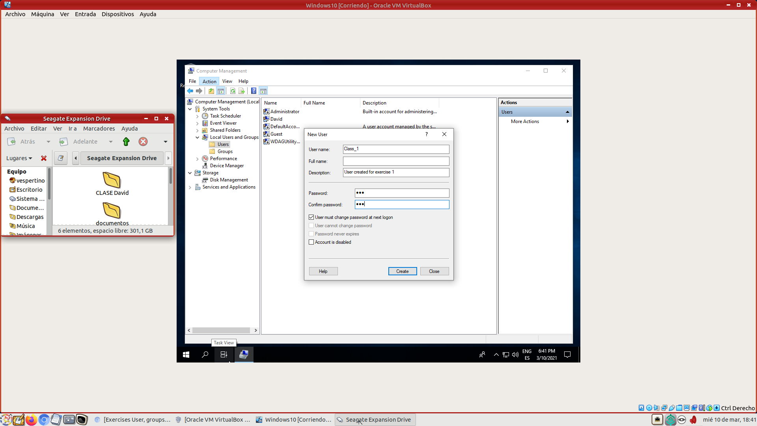

**2.-**

By the moment, the folder doesn’t exist.

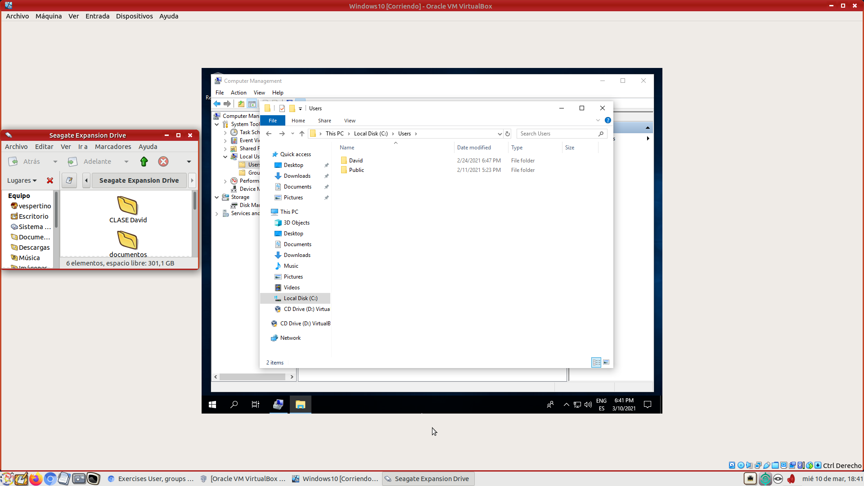

We login into class1 user and the folder is now shown.

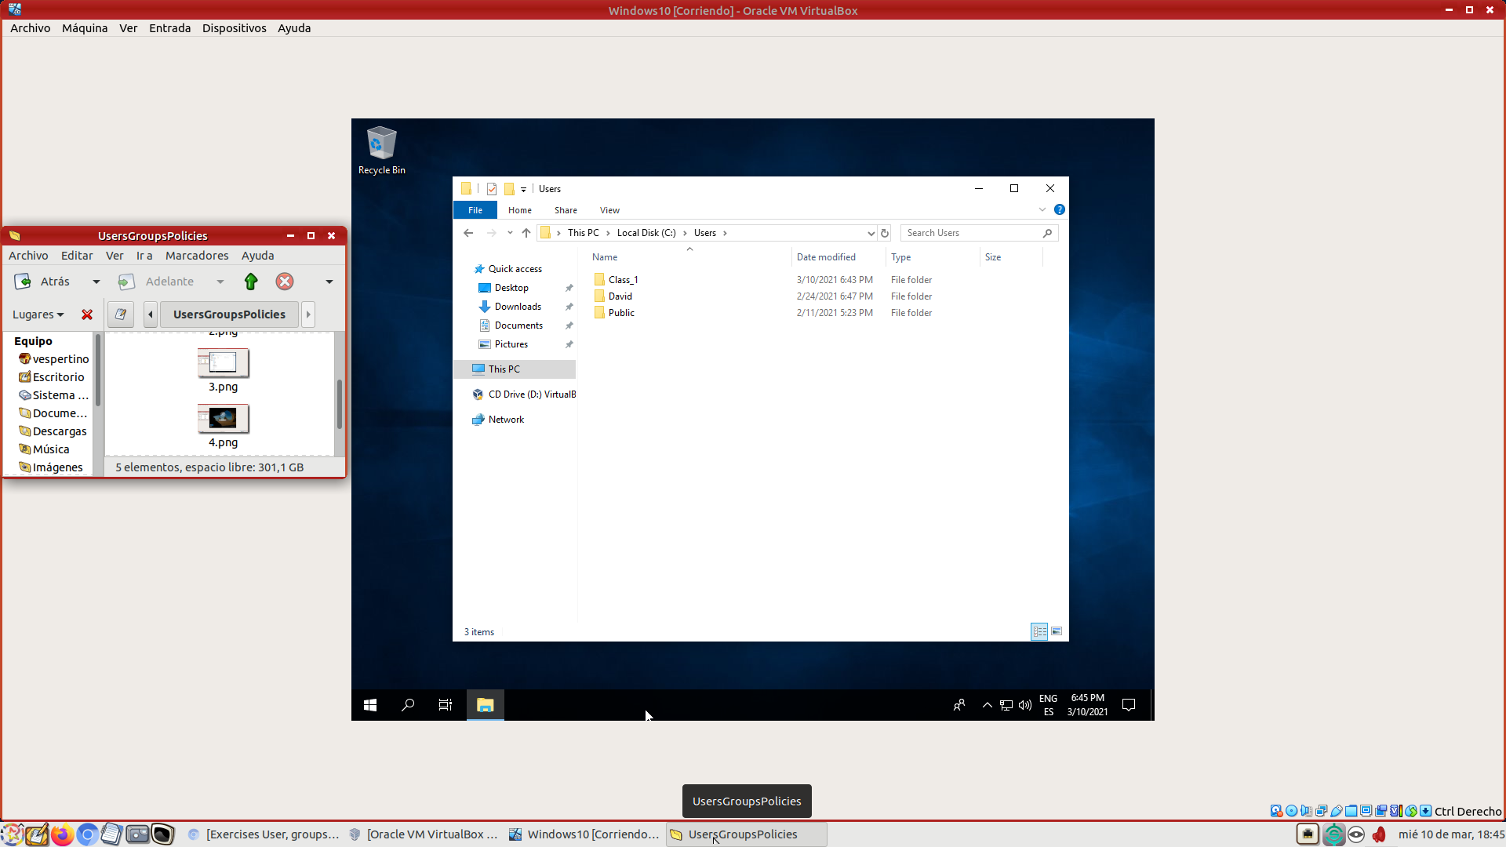

First, we need to create a new virtual disk from VirtualBox and then, from computer management->disk management create a new volume. 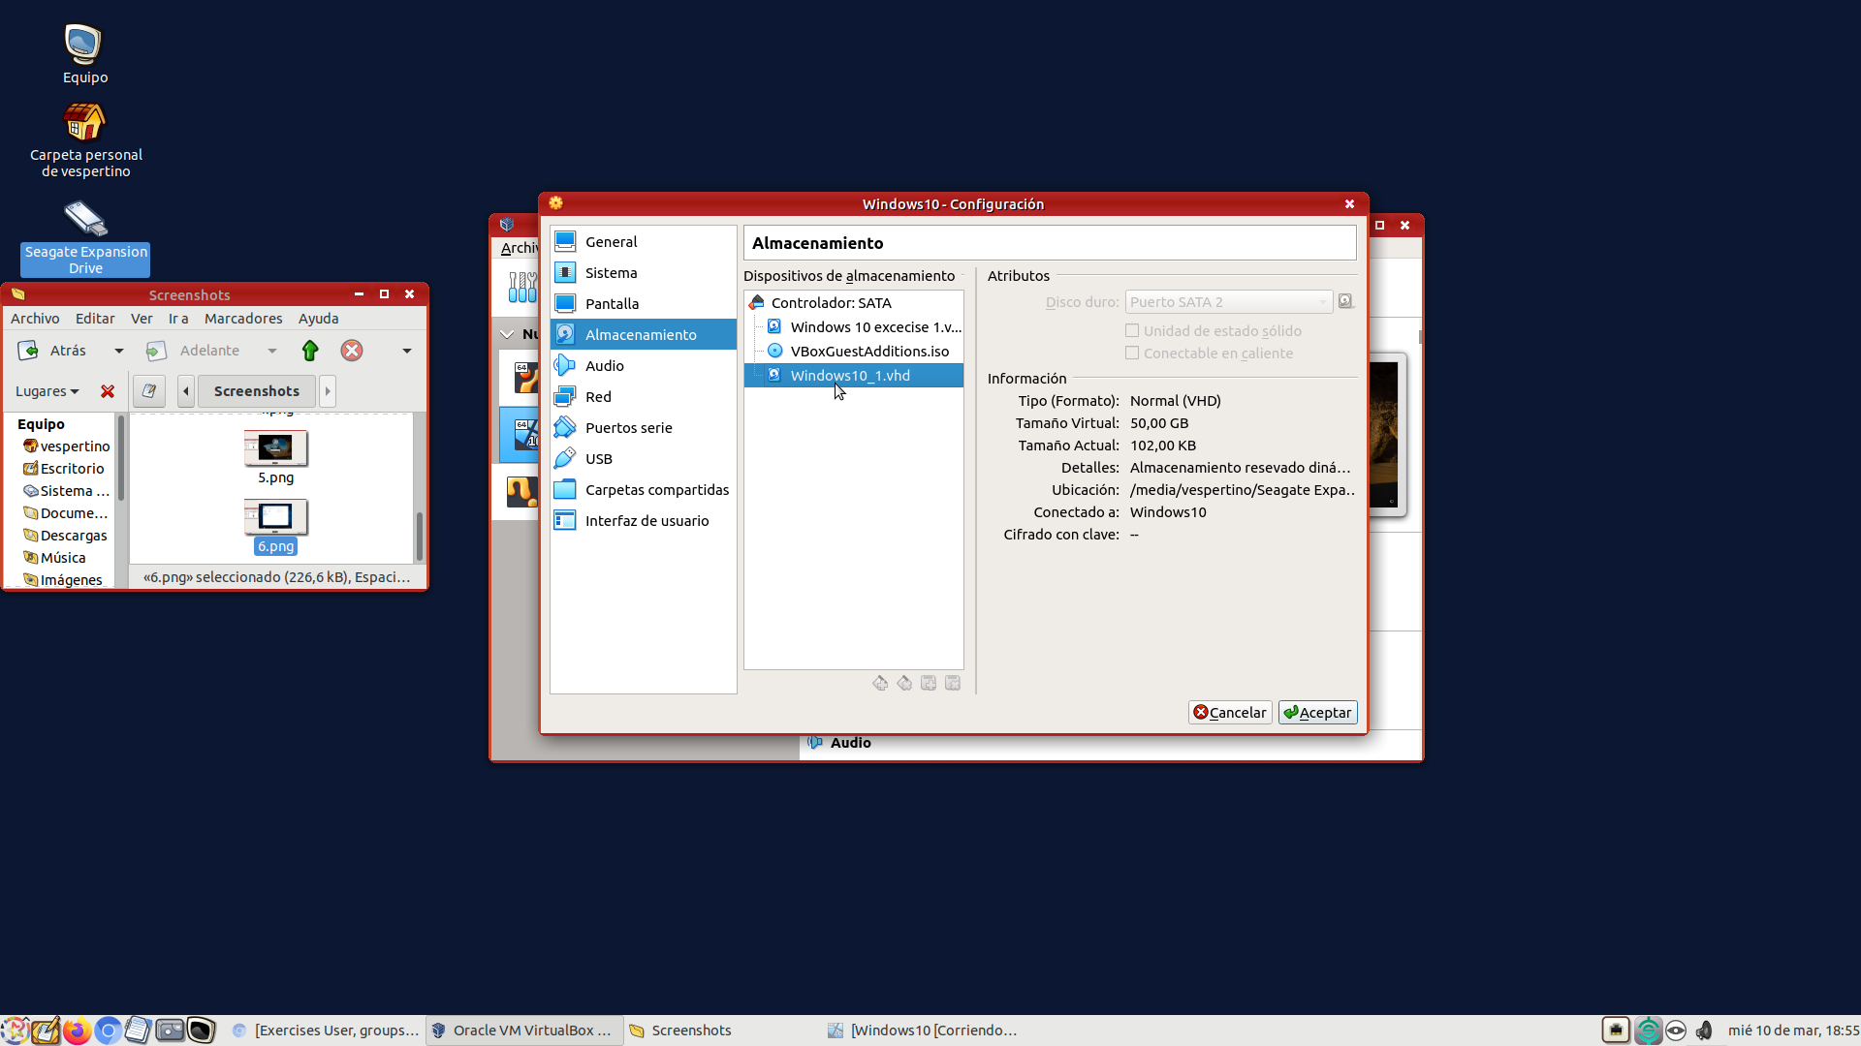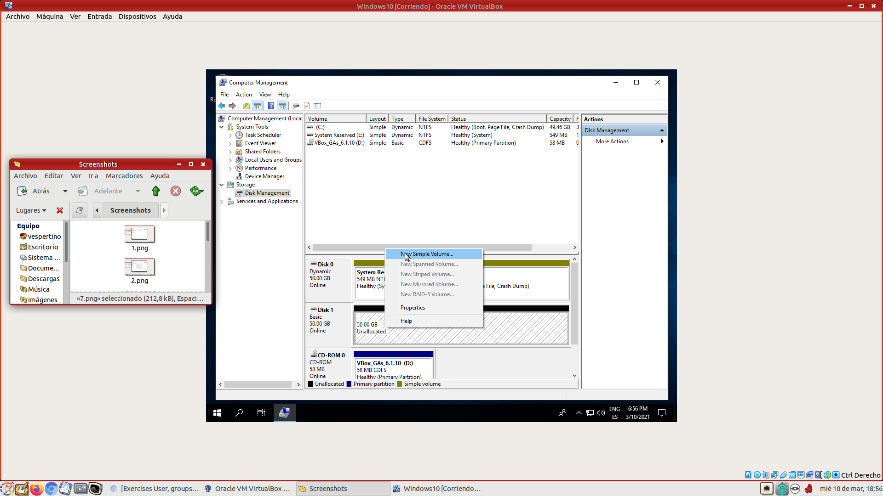

We create the folder and the move Documents by rigth-clicking on it and going to properties->move and select the folder created. 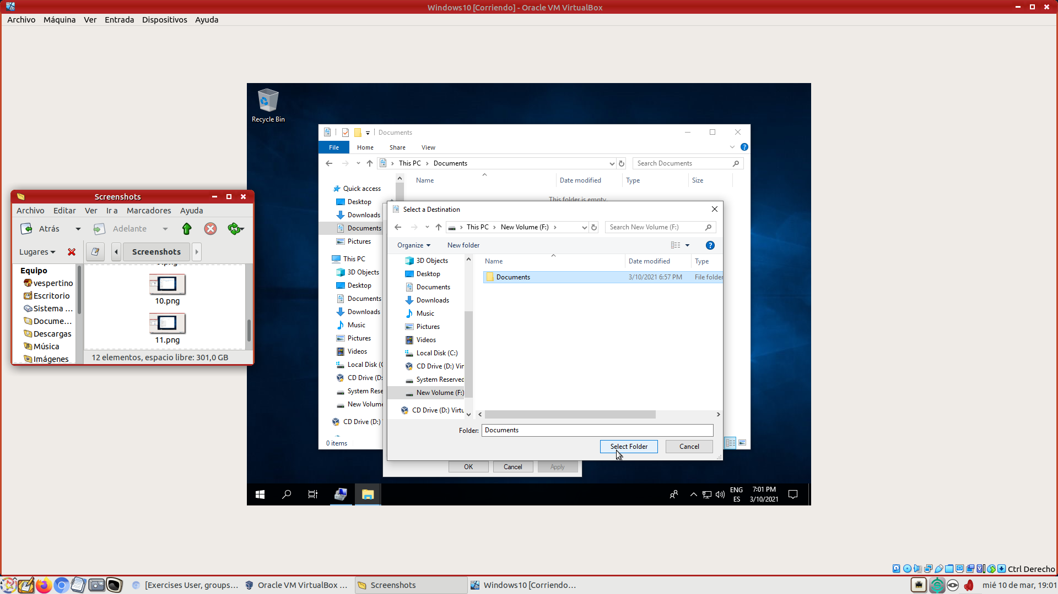

We create a new folder in the shortcut and the check if it exists in the new volume. 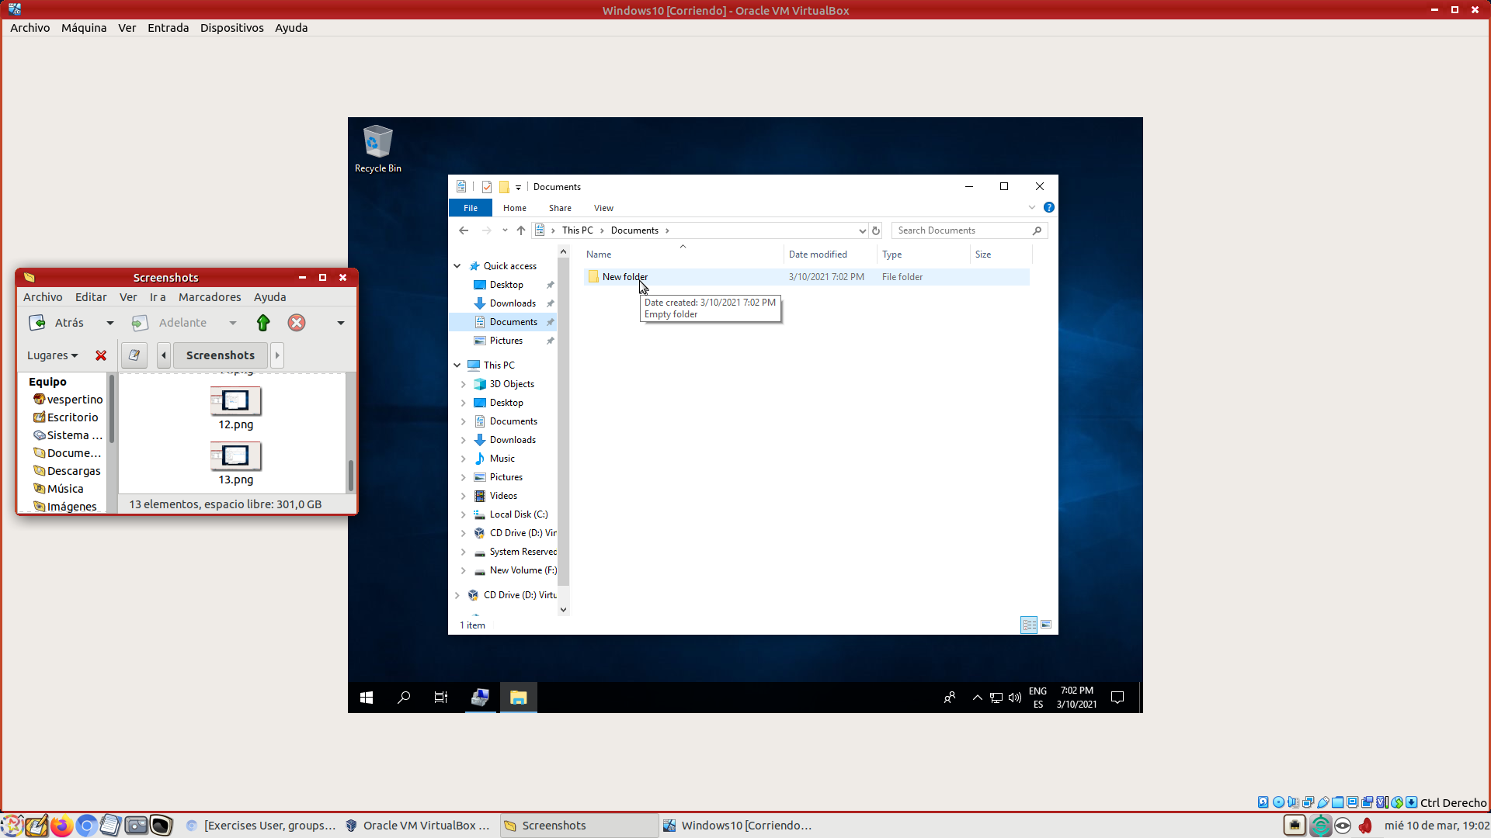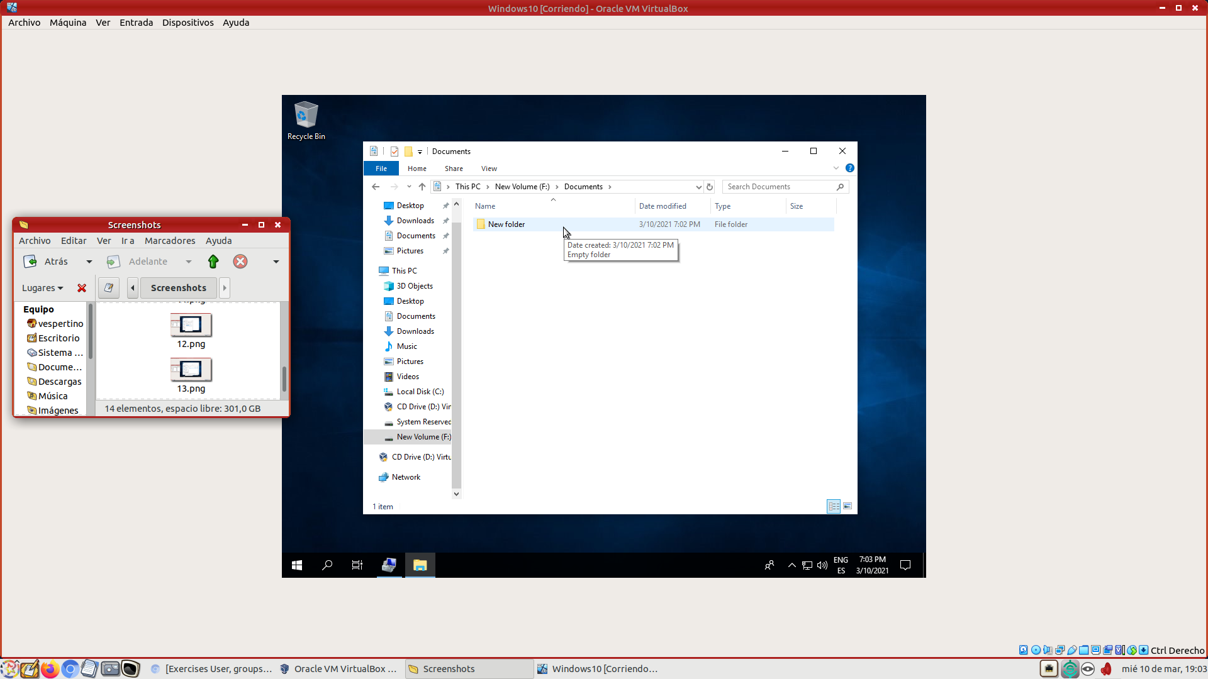

**4.-**

For a specific user, we need to go to our user in computer management, select properties and check the “password never expires” checkbox.

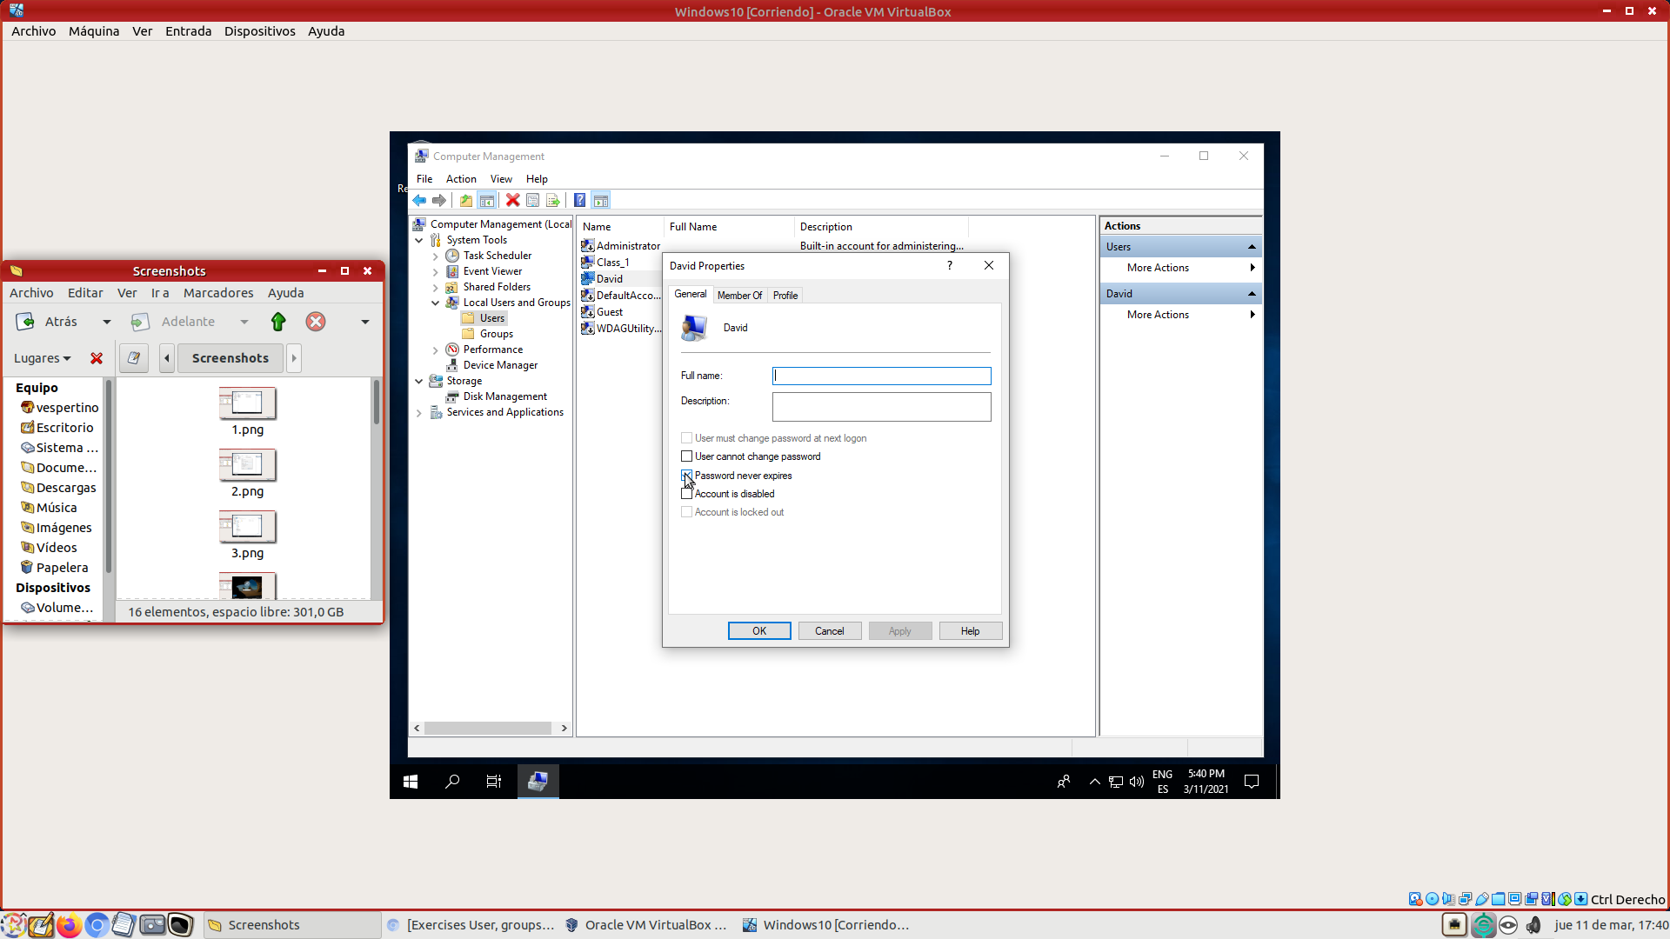

For every user, we need to go to the local security policies window , select account policies -> password policies -> maximum password age and type 0 days. 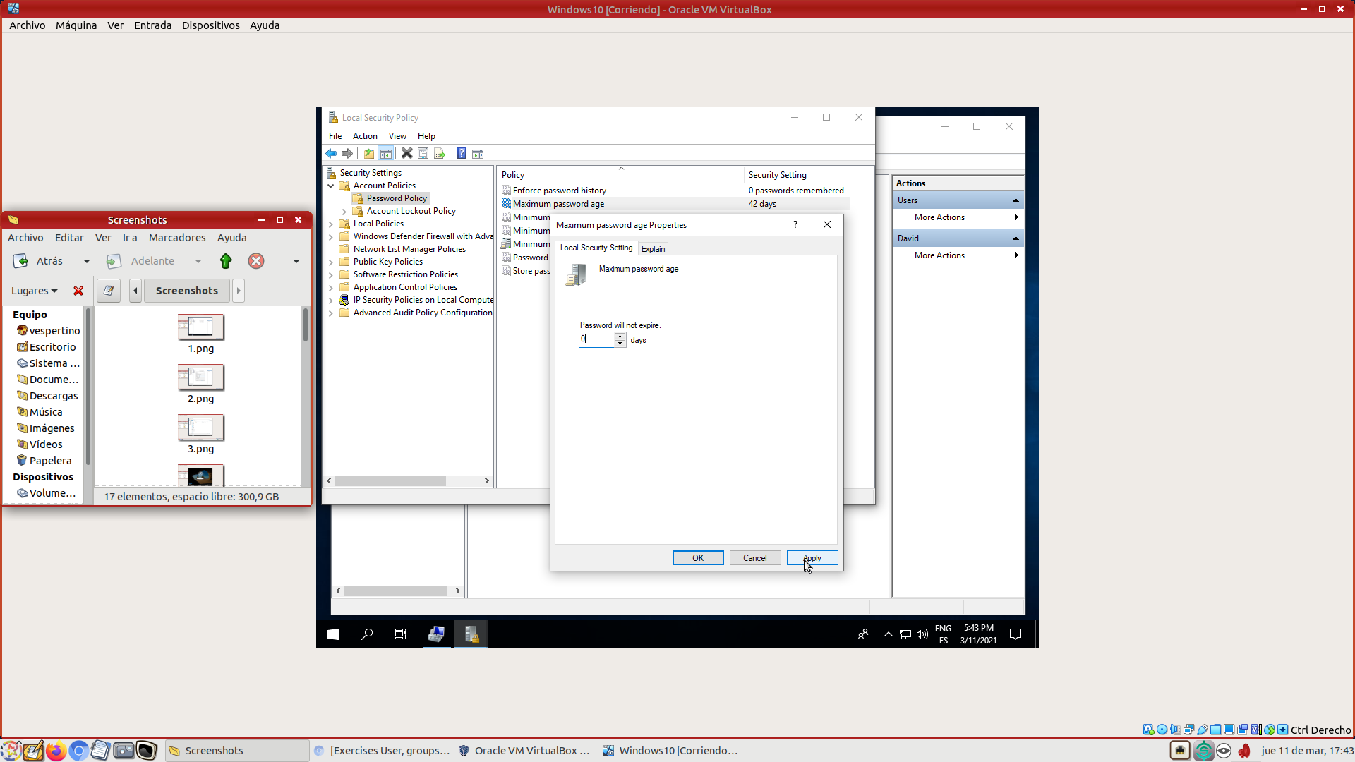

**5.-**

We can wether wait untill the user automaticly unlocks (if the locked state is temporally) of go the user properties with the administrator account and deselect the account locked checkbox.

**6.-**

The correct value is 5 minutes, if it is greater than the account lockout duration value, the user won’t be able to access the account even after 5 minutes.

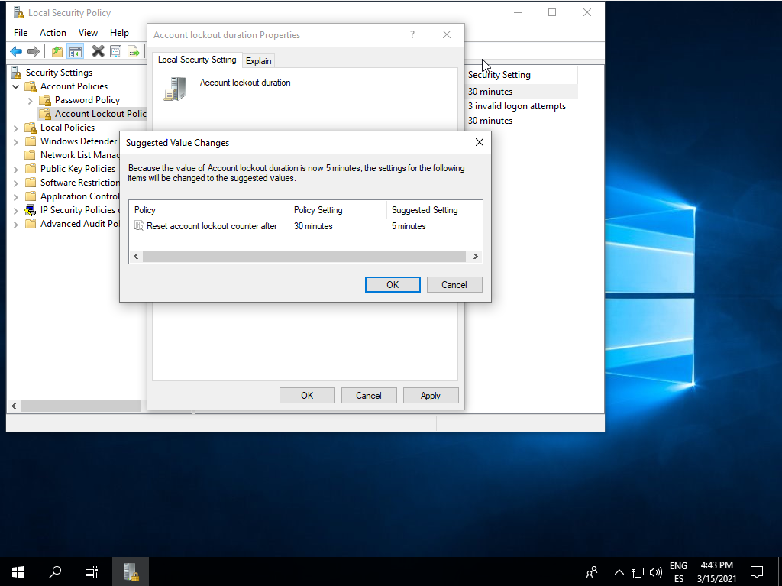

If the Account lockout threshold is 0 the other values must be not applicable, because there isn’t a lockout condition.

**7.-**

Store 10 passwords:

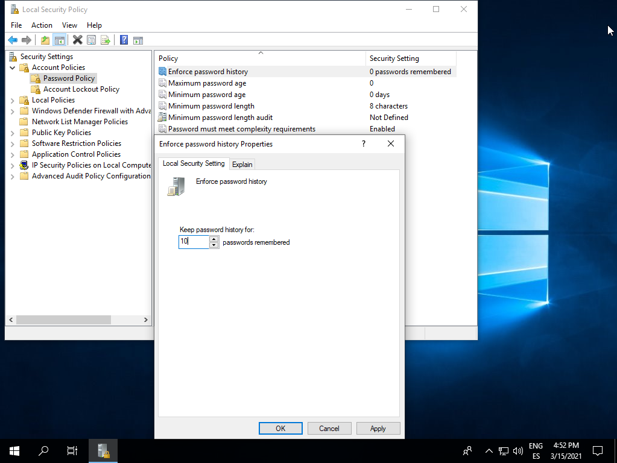

Complexity requirements:

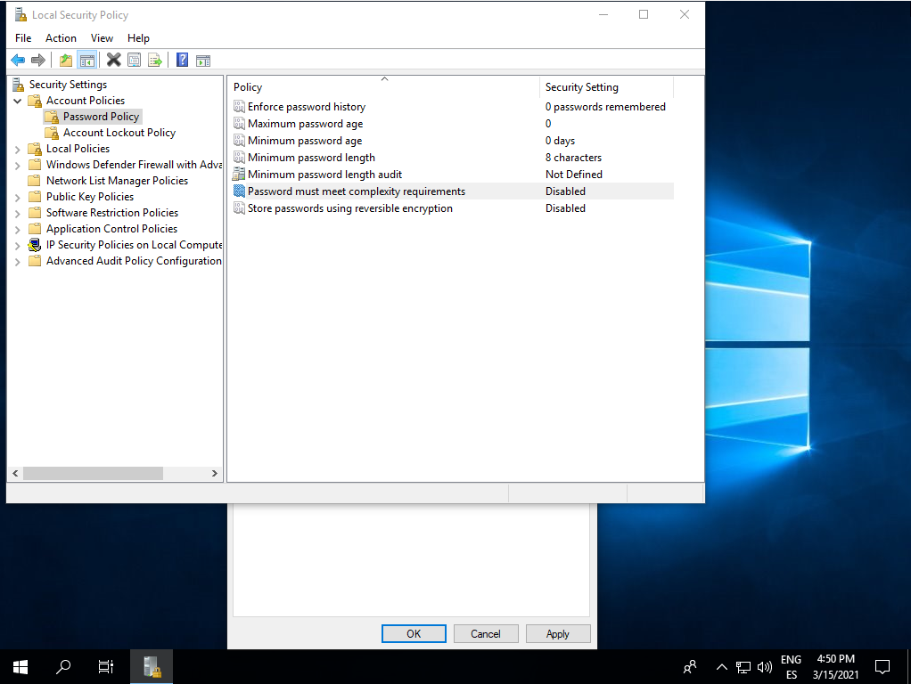

Minumum password characters length:

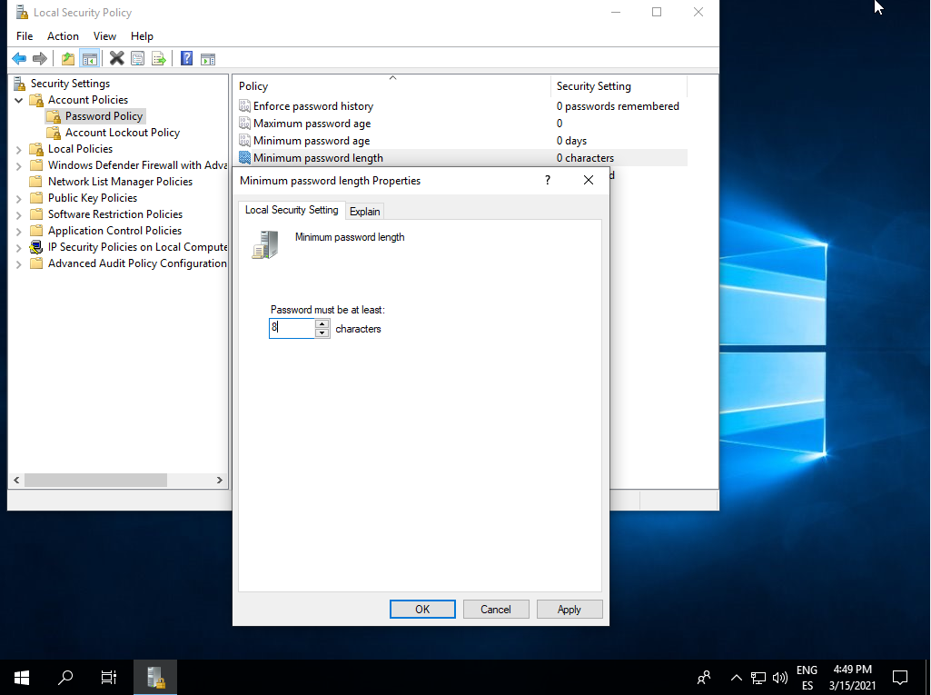

Passwords expire after 3 months:

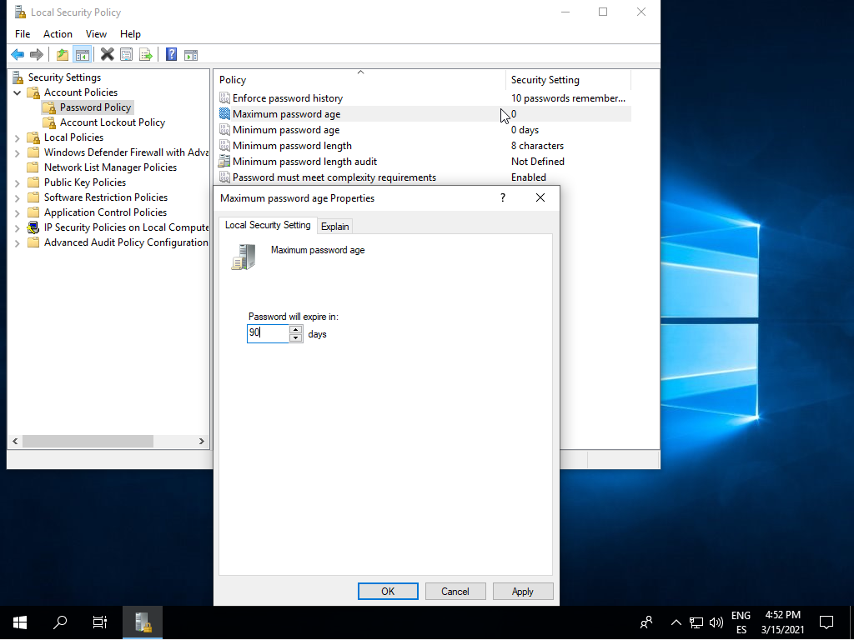

**8.-**

We will lock the user by typing 3 times a wrong password. 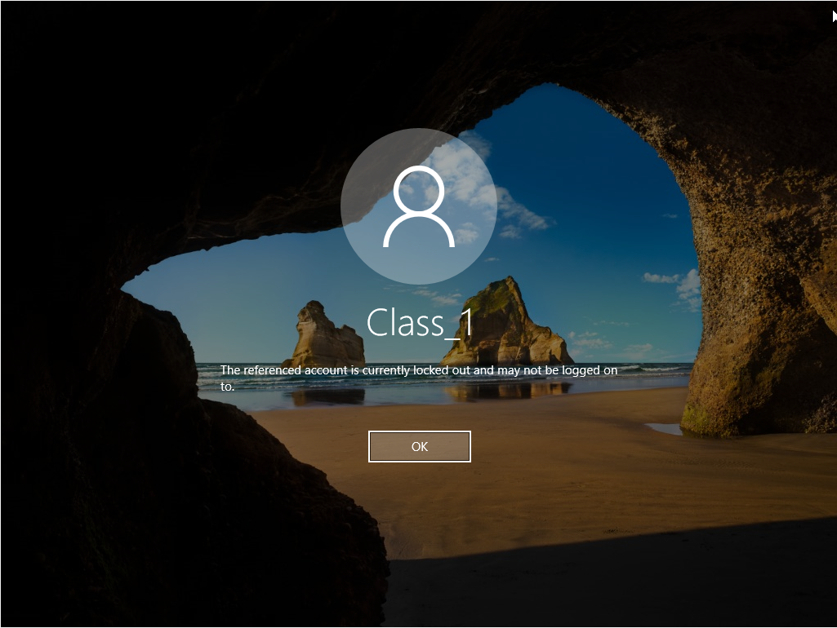

Then we will log in with the administrator user and go to computer management -> users -> class_1 and deselect the Account is locked out checkbox.

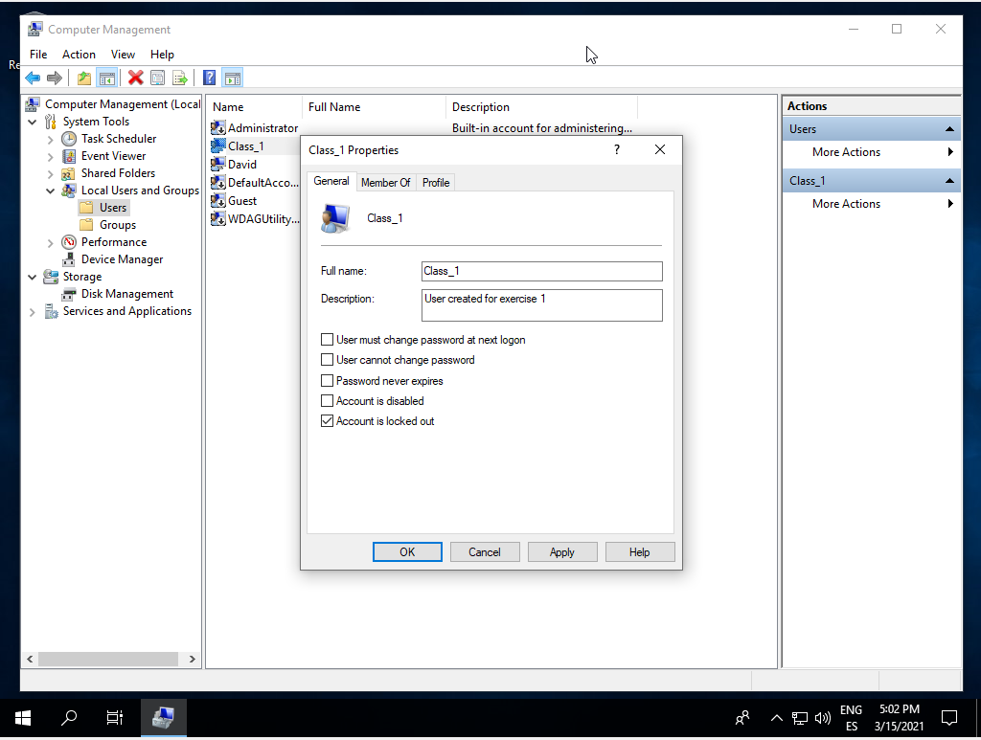

We will lock the user again the same way and wait 5 minutes. In both attemps we will be able to log in with Class_1 user.

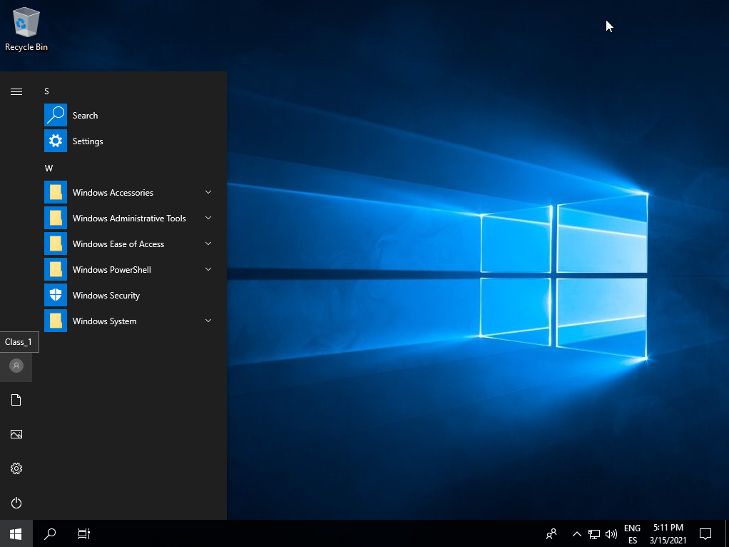

**9.-**

First, we will go to groups in computer management and click on action -> new group.

Then Introduce the name and click on add member, we will type Class_1 and click on

Check name then OK and then create.

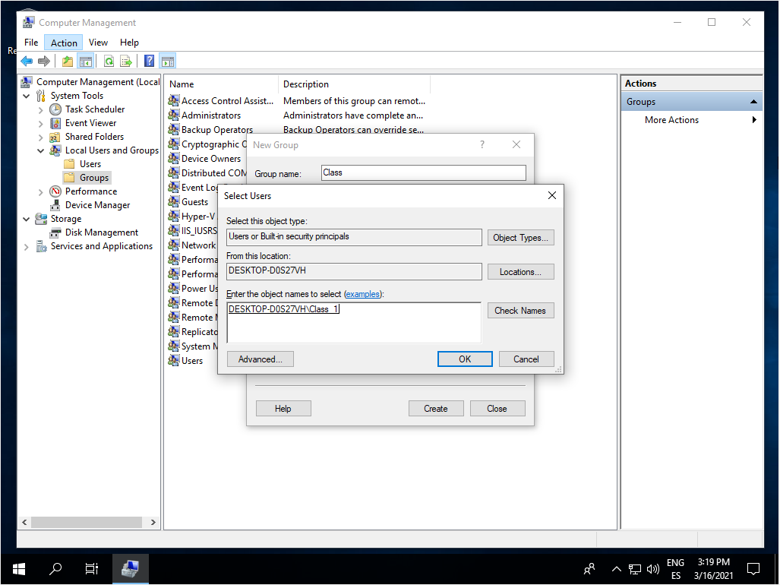

Then we will create the user Class_2 with the “user cannot change password” and “account is disabled” checkboxes marked. 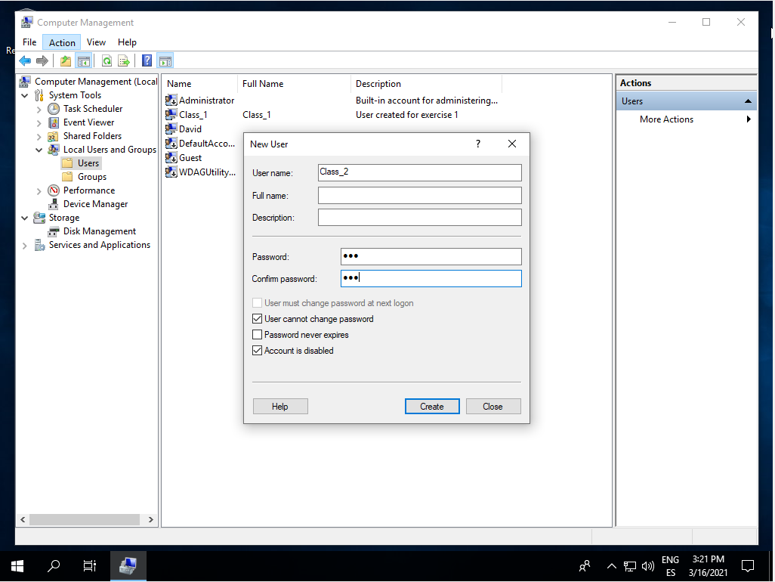

Then click on the new user, go to member of section and click on add. We will type Class, check name and ok. Then do the same with Guests instead of Class. 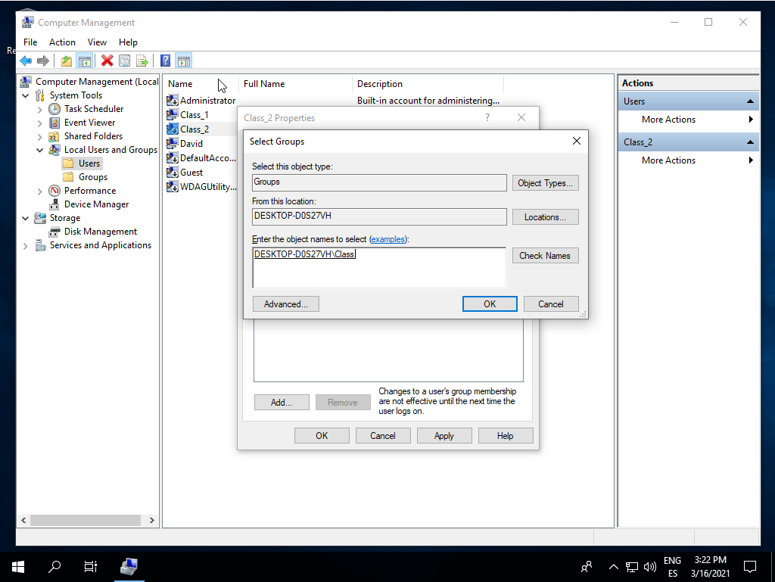

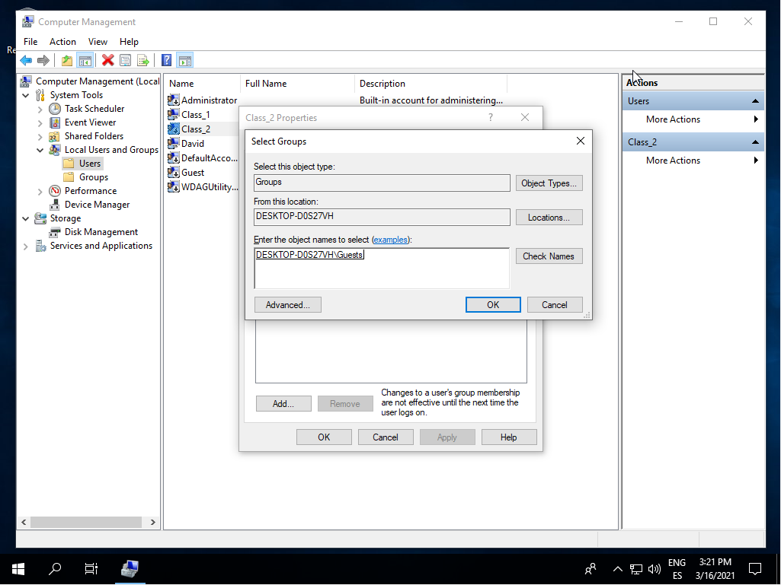

**10.-**

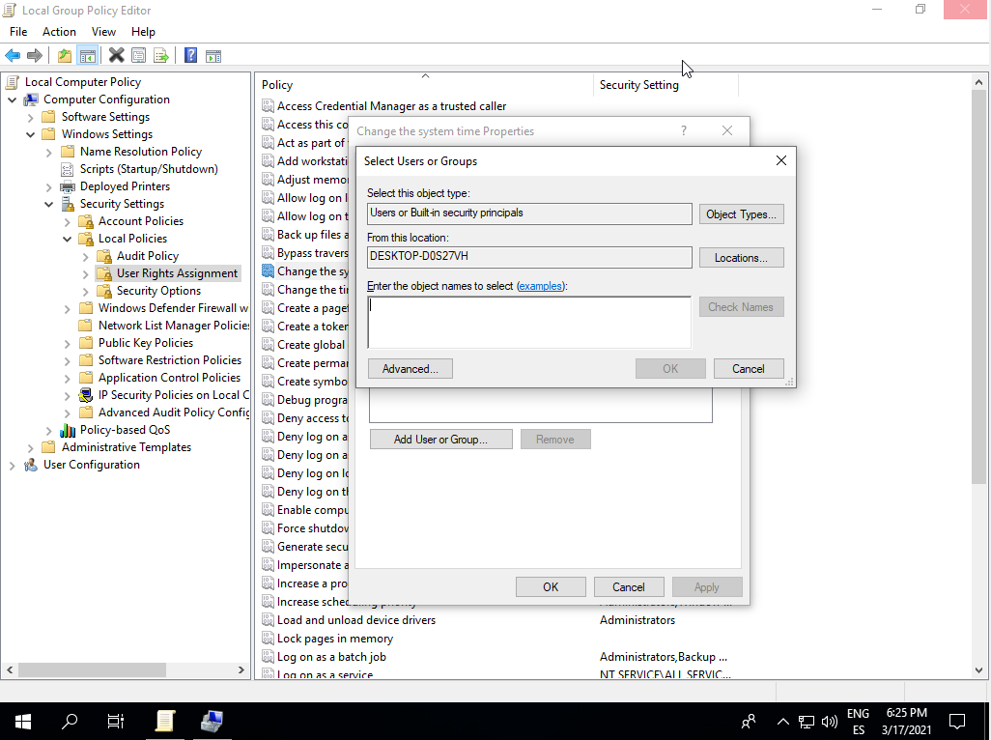

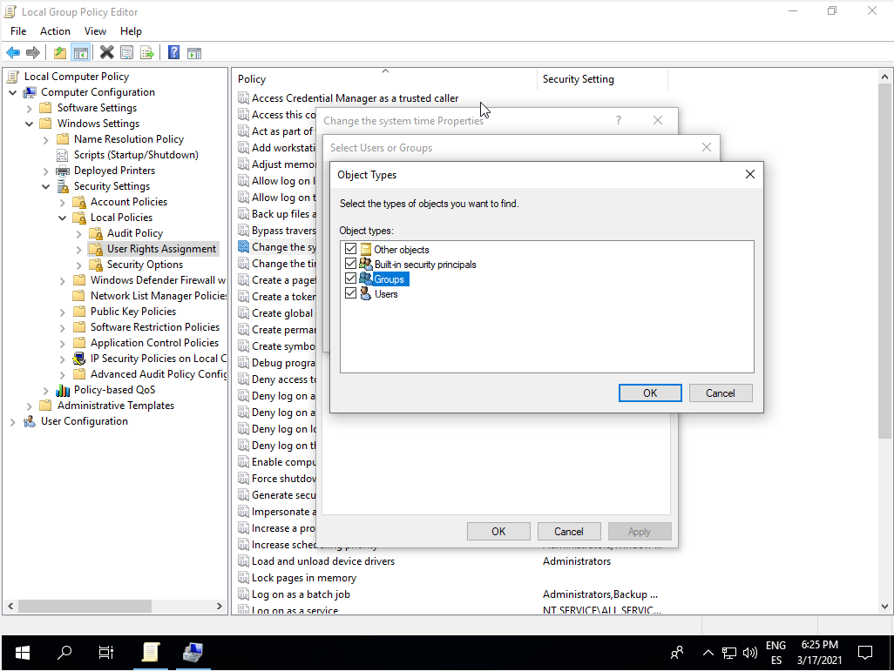

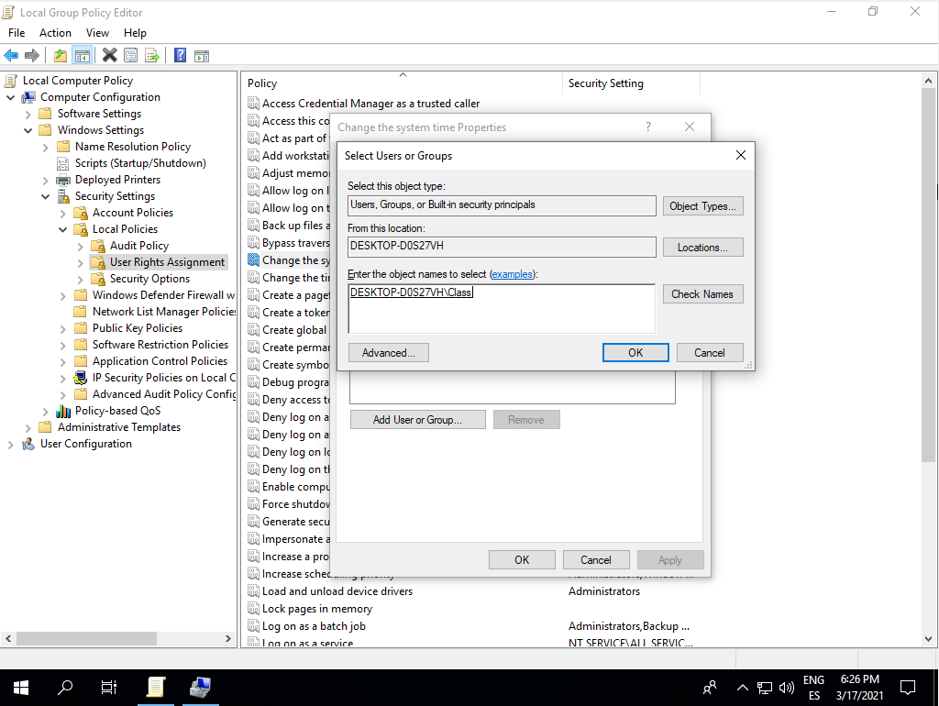

**11.-**

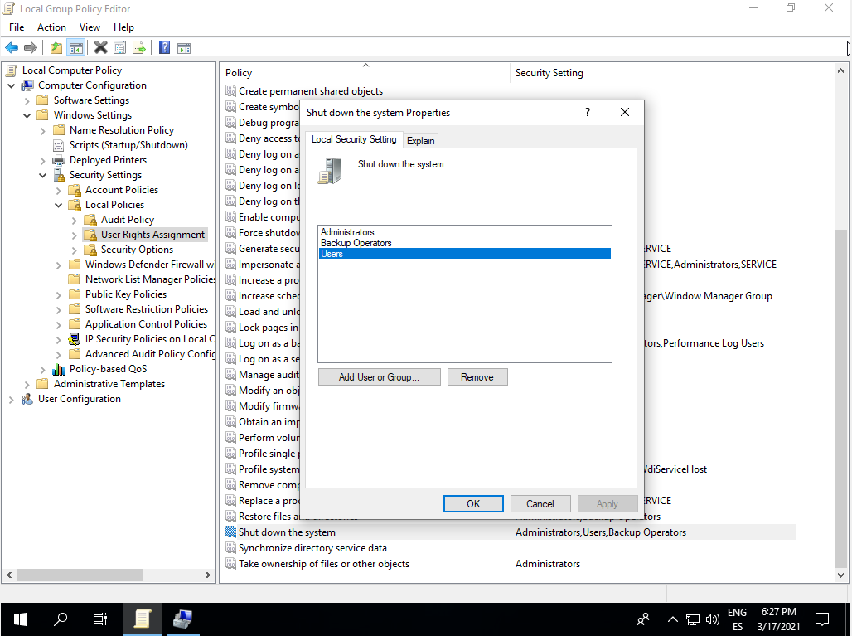

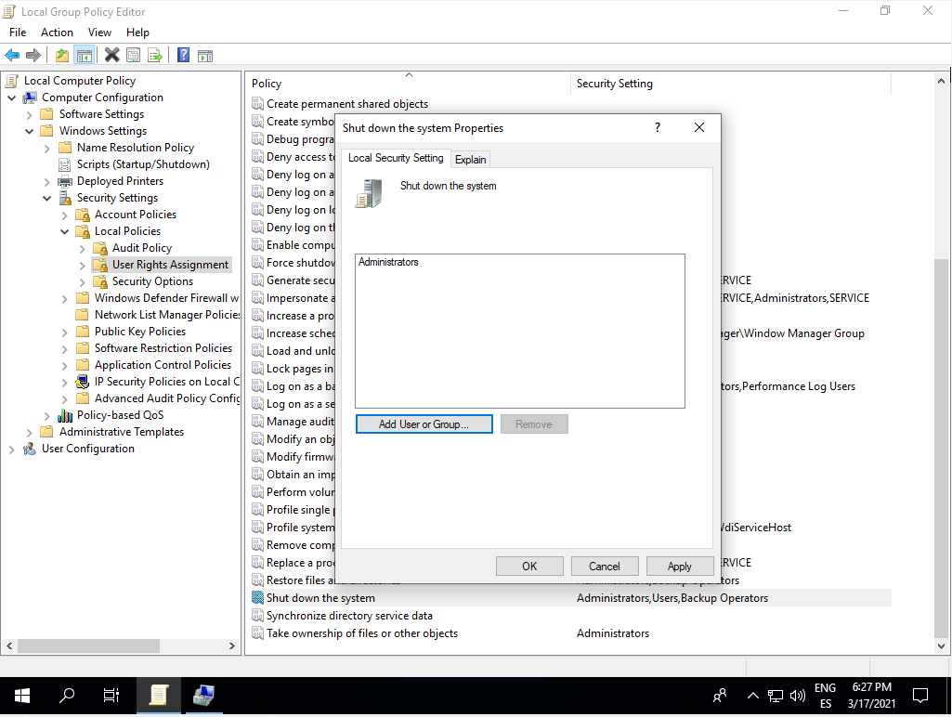

**12.-**

